86 Audley Road
Hendon
London
NW4 3HB

20 Derwent Crescent
London
N20 0QQ

Tel: 020 8203 5150

38 Wentworth Avenue
Finchley
London
N3 1YL

Tel: 020 8346 1242

www.wentworthmedical.nhs.uk

wentworth.mp@nhs.net

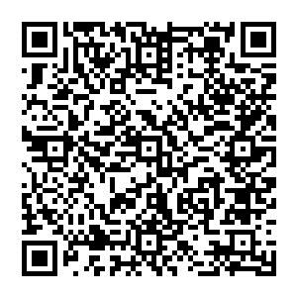
01.11.2023

Dear Patient

Re: Derwent Crescent branch - Practice possible relocation to Wentworth Medical Practice 38 Wentworth Avenue London N3 1YL

We would like to notify you that the current arrangement with the lease for Derwent Medical Practice landlords ends in March 2024. This means that Derwent Medical premises will no longer be available for primary care services. We will though write to you again to confirm when this will occur, and you will still continue to be seen at both practice sites.

Wentworth Branch at Derwent Crescent: 20 Derwent Cres, London N20 0QQ
Wentworth Medical Practice main site: 38 Wentworth Ave, London N3 1YL

We wanted to take this opportunity to reassure you that all the GPs and staff will remain the same, and all the services you currently receive from the GPs and Nurses will continue.

We are also writing to you as we are required to seek your views on the potential closure of the Derwent site and to ensure that we address any of your needs, specifically with distance to travel, transport routes, parking and access to GP appointments.

Wentworth Medical Practice is approximately 1.5 miles from Derwent Crescent about 6 minutes by car, approximately 21 minutes by bus served by bus route 125, it is roughly a 33 minutes’ walk. The nearest tube is West Finchley tube station (Northern Line). There is also parking available at Wentworth Medical Practice and close to Wentworth practice.

You can share your views, by using the following methods.

Completing the online survey by following the link below:
https://feedback.camdenccg.nhs.uk/primary-care/derwent-crescent-survey

or by scanning the QR code at the top of this letter on your mobile device

• Complete a paper survey, which is available from the practice reception, once completed you can hand it back to the reception staff at the surgery.

Or send your response via email to the practice on nclicb.wentworthgrouppracticepm@nhs.net

The survey will close on 30 November 2023 and all responses to the survey will be anonymous. We will write to all patients again to update you about the outcome following a decision by the North Central London Integrated Care Board (ICB).

If you need further information, please contact us via e-mail on: nclicb.wentworthgrouppracticepm@nhs.net

Yours sincerely

Dr Anuj Patel Dr Leena Mistry

GP Partner GP Partner

